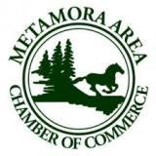

We are hoping you can join us on December 6, 2020 in Metamora, Michigan for the annual Wassail Weekend Horse and Carriage Holiday Parade hosted by the Metamora Area Chamber of Commerce.
No fire engines, no bands, no motorcycles
JUST HORSES!

Awards will be given in several categories and every participant receives a commemorative ornament.

The Metamora Area Chamber of Commerce

Invites you to participate in the

METAMORA WASSAIL CELEBRATION
HORSE AND CARRIAGE HOLIDAY PARADE
SUNDAY Afternoon, DECEMBER 6, 2020
With costumes and carolers, snowflakes and scarves, mistletoe and merriment comes the Wassail Horse and Carriage Holiday Parade! Riders and drivers alike are invited to parade through Metamora in holiday attire while the local community and visitors gather in downtown Metamora to watch participants ride and drive through town.
Currier and Ives costumes and 19th Century Victorian Seasonal Attire are strongly encouraged.
❖
❖
❖
❖
❖
❖
❖
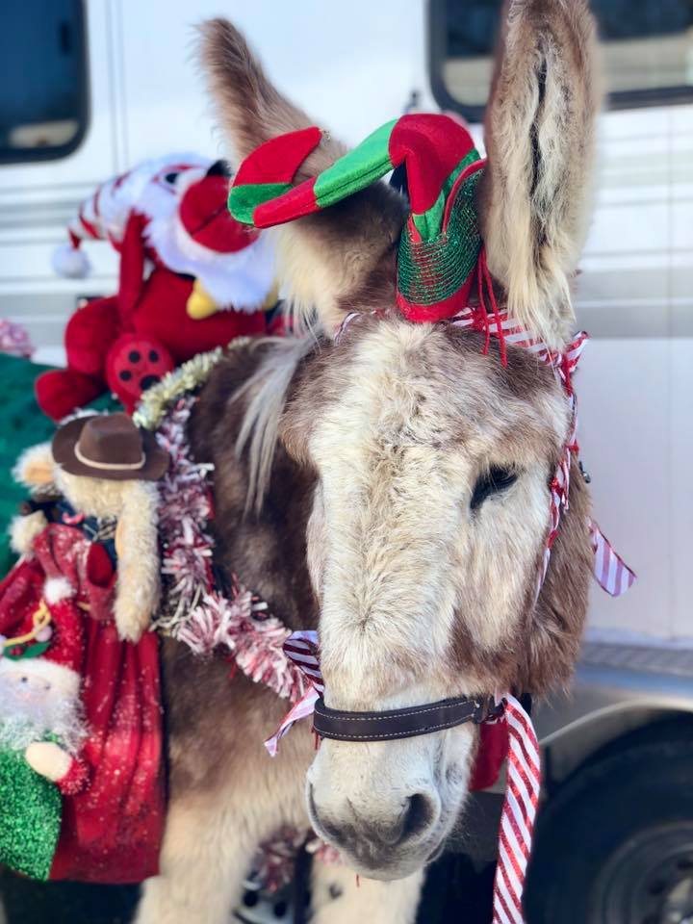 | 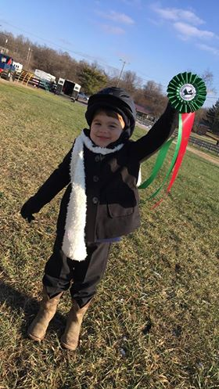 | 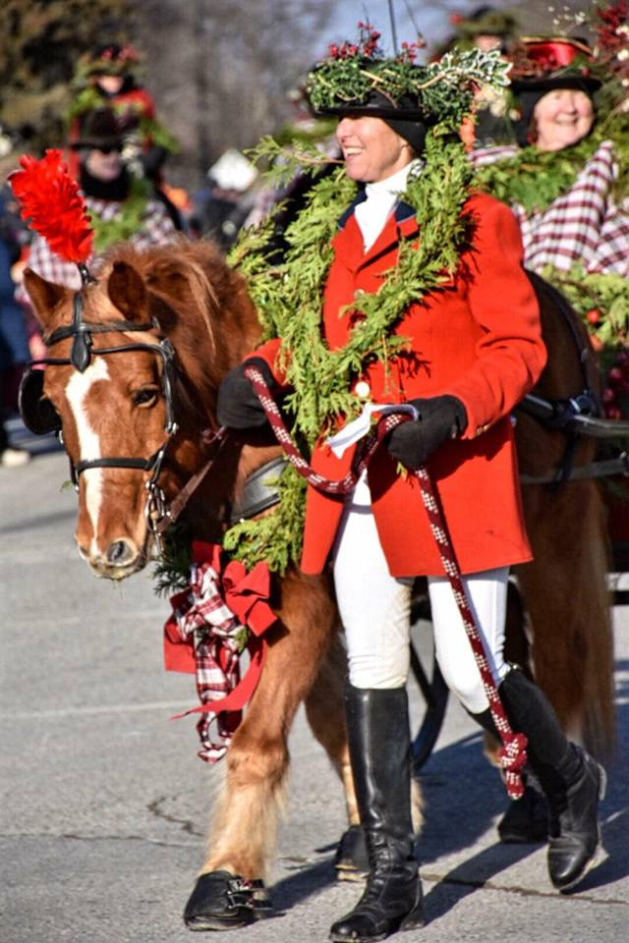
Award Categories for 2020 Wassail Parade:

Best Individual Costume, Best Group, Best Horse Drawn Vehicle, Most Seasonally Attired,

Best Junior Entry, & Several Judges Award
Bring out those saddles and harnesses and join us for a merry holiday afternoon!

Please be aware that the Wassail Celebration will draw many spectators. Please help keep this event safe and fun for spectators and participants alike by bringing your own walkers.

PARADE DETAILS & TIMELINE
A confirmation letter will be sent to you with more details but here is some information to get you started…
 12pm-1pm: Participants will gather at the staging area. Packets with bridle numbers will be handed out upon your arrival and check-in.
 1:30pm: Parade Line-Up - participants will hitch and mount up in numerical order for the parade
 Judging will begin
 2:00pm: Parade Departure from the staging area

To ensure inclusion in the program, complete the listing, sign and return this registration form by:
November 20
Wassail Parade
For questions please contact:

Mary Chris Foxworthy 810-667-3375

WASSAIL PARADE ENTRY FORM

Name of Entry:
Contact Name:
Address:
City, State, Zip:
Telephone:
Email:
Entry is: | _____Horse and Carriage Combination _____Horse and Rider Combination _____Both
Number of people in your group_____ Number of horses in your group_____
Number of horse trailers in your group_______
Script for Announcer: Include the name of riders or passengers, the breed and name of horse, and a description of the costume and conveyance.

** PARADE WALKERS ARE REQUIRED FOR EACH ENTRY **
Parade walkers help the horses and riders during the parade and are vital for the safety of parade participants and spectators alike. This is a fun, easy way to enjoy the parade from a front row seat! Each participant should bring their own walkers (festive attire/costumes encouraged) to help keep everything running smoothly and safely. Please include their names on the release form as well.
See next page for more information AND REQUIRED SIGNATURES

WASSAIL PARADE RELEASE FORM
A SIGNATURE IS REQUIRED FOR EVERY PARTICIPANT –
THIS INCLUDES ALL RIDERS, DRIVERS, PASSENGERS & WALKERS

FOR MINORS, THIS MEANS THE SIGNATURE OF A PARENT OR GUARDIAN.
I hereby enter my horse at my own risk, subject to all the rules and regulations of this event. I further agree that if any injury occurs to me or my horse, or to any equipment that I may use or send for use in this event, I will make no claim wherefore against the Metamora Area Chamber of Commerce, Metamora Wassail Committee, the Village of Metamora or any spectator. I further agree to hold the Metamora Area Chamber of Commerce, Metamora Wassail Committee, and the Village of Metamora harmless from any liability, claims, suits, or damages of whatsoever kind or nature that may be occasioned by the horse used by me or by the negligence of the persons in charge of other horses, and I agree to indemnify and hold harmless these organizations and individuals against all liability, claims, suits and expenses including attorney fees incurred, arising out of any injury to any person or damage to any property caused by me.
Name Address
Signature Date
Name Address
Signature Date
Name Address
Signature Date
Name Address
Signature Date
Name Address
Signature Date

- must receive a copy of negative Coggins test (dated within last 12 months) in advance with entry

To ensure inclusion in the program return this registration form by
November 20

Wassail Parade

100 W. Sutton Rd.
Metamora, MI 48455
Phone: ((810)- 667-3375
info@metamorachamber.org
www.metamorachamber.org

