Dear Friend,

We are ready to celebrate the 41st anniversary year of Metamora Country Days and Hot Air Balloon Festival sponsored by the Metamora Area Chamber of Commerce.

Thousands of people ranging in age from infancy to older adult attend this event with visitors coming from several surrounding counties.

The Metamora Area Chamber of Commerce is asking for your support. The success of Metamora Country Days and Hot Air Balloon Festival depends on donations and sponsorships to pay for the cost of the festival.

Your early commitment will enable the committee to move forward on planning one of the finest events in our area. We need to have your sponsorship by August 1 in order for you to be included in print advertising and to have balloon banners printed.

Please review the enclosed information about sponsorship opportunities. If you have any questions, please contact us.

Thank you in advance for your commitment to support Metamora Country Days and Hot Air Balloon Festival.

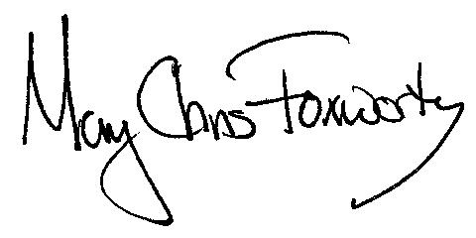
Mary Chris Foxworthy
Metamora Chamber of Commerce Executive Director

